**IDEATION PHASE**

**DEFINE THE PROBLEM STATEMENTS**

|  |  |
| --- | --- |
| Date | 26-09-2022 |
| Team ID | PNT2022TMID51001 |
| Project name | Estimate The Crop Yield Using Data Analytics |
| Maximum marks | 2 marks |

**CUSTOMER PROBLEM STATEMENT:**

Crop production in India is one of the most important sources of income and India is one of the top countries to produce crops. As per this project we will be analyzing some important visualization, creating a dashboard using a IBM cognos and by going through these we will get most of the insights of Crop production in India.

**Examples:**

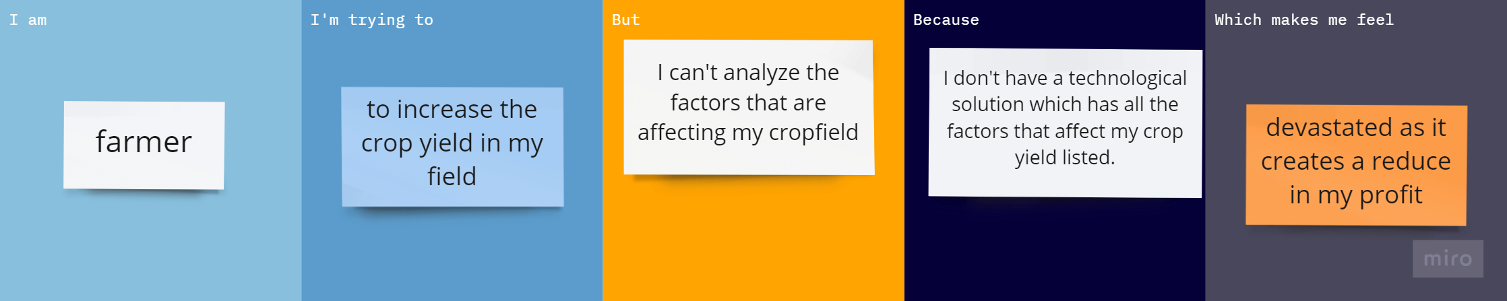

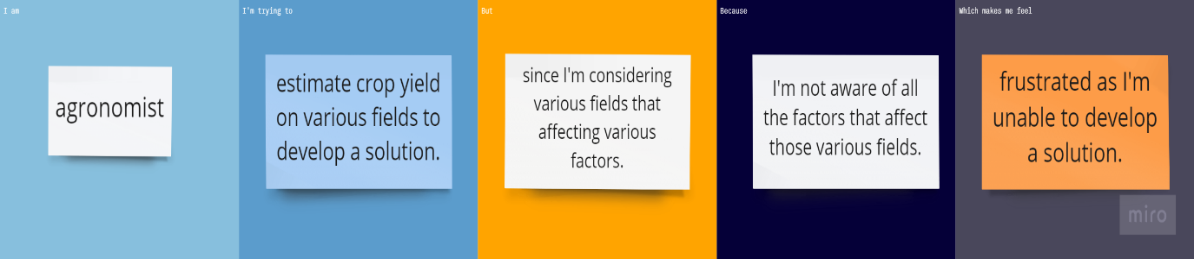



|  |  |  |  |  |  |
| --- | --- | --- | --- | --- | --- |
| **Problem Statement(PS)** | **I am**  **(Customer)** | **I’m trying to** | **But** | **Because** | **Which makes me feel** |
| PS-1 | farmer | To increase the crop yield in my field. | I can’t analyse  the factors that are affecting my crop field . | I don’t have a technological solution which has all the factors that affect my crop yield listed. | devastated as it creates a reduce in my profit. |
| PS-2 | agronomist | Estimate crop yield on various fields to develop a solution. | Since I’m considering various fields that affecting various factors. | I’m not aware of all the factors that affects those various fields. | Frustrated as I’m unable to develop a solution. |
| PS-3 | Lecturer in an agricultural university | Know the factors which are affecting the crop yield. | I’m unable to do it as I’m aware that various fields are affected by various factors. | Various fields differ in the factors that affect their crop yield. | Sad as I have not gained enough knowledge. |